Quarterly Report – Public Page

Date of Report: 8th Quarterly Report – September 30, 2025
Contract Number: 693JK32310007POTA
Prepared for: DOT-PHMSA
Project Title: An Integrated Knowledge Graph Model for Geohazard Monitoring Data
Prepared by: University of Wyoming
Contact Information: Dr. Minou Rabiei, mrabiei@uwyo.edu
For quarterly period ending: September 30, 2025
1: Items Completed During this Quarterly Period:
- Completed the design and construction of knowledge graph model

2: Items Not-Completed During this Quarterly Period:
- Link external data sources and perform semantic enrichment (On-going)
- Develop the graph neural network model (On-going)
- Perform advanced spatiotemporal analysis (GNN-based)

Justification: This quarter we prioritized finalizing the ontology and aligning datasets to the new schema. External linkages, continue as data-use agreements and ETL crosswalks complete. GNN development and spatiotemporal analysis are scheduled to begin after the ontology/data alignment milestones are locked.
3: Project Financial Tracking During this Quarterly Period:

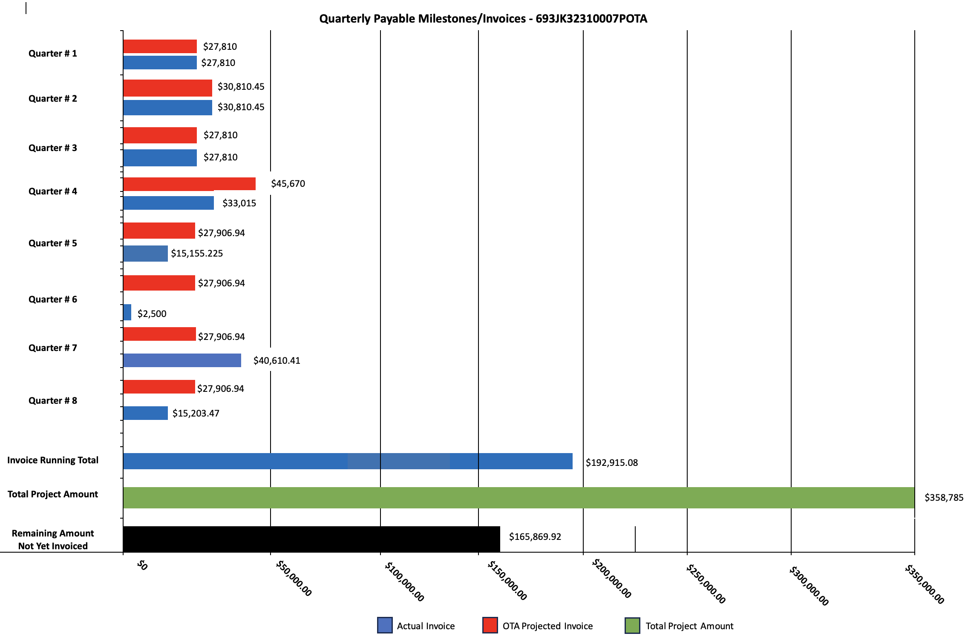

4: Project Technical Status

- Design and construction of knowledge graph model:
Delivered Ontology v1.2 with:
- Indicators module for non-model layers
- Hazard subclasses mapped to modeling approaches
- PHMSA/NPMS mapping
- SKOS code lists
- Basic SHACL
- H3 alignment as a first-class spatial index for observations/joins.

- Link external data sources & semantic enrichment – Ongoing
- Maintained provenance (PROV) for all ingested sources; extended ETL to normalize to H3 and Regions
- Continued crosswalks for event catalogs (USGS earthquakes) and administrative geographies (FIPS).
- Began assembling SPARQL templates for county/H3 rollups and hazard-to-segment impact joins.

- Develop the graph neural network model – Ongoing

- Finalized feature schema for training data (segment-centric features joined from indicators and hazards).
- Drafted GNN problem framing (risk scoring as node-level prediction; temporal slices at monthly intervals using H3-aggregated indicators).
- Implementation starts next quarter after final data linkage checks.

Next Steps
- Finish schema validation & units: Add SHACL for all hazard subclasses and PHMSA fields; standardize numeric units with QUDT; finalize deprecations/aliases.
- Complete data linkage & H3 normalization : Finish NSHM/faults/FEMA ingests; build H3↔County/HUC-12 bridge tables; assert event→region links at load time.
- Add pipeline topology (network model): Model nodes/valves/stations and segment-to-segment adjacency to enable network-aware impact and routing queries.
- Harden provenance: Require record-level PROV on all hazards and a standardized ModelRun schema (parameters, versions, run IDs).
- Deliver analytics & queries: Train a baseline GNN for segment risk (with calibration/uncertainty) and publish a concise SPARQL template pack.
- Update visuals: Regenerate the ontology diagram (including Indicators) with a legend and 3–4 “how-to” query examples.

